
As writers, we will use:
Use a variety of verbs
Use similes to describe
Use a range of conjunctions (subordinating and coordinating)
Use a range of modal verbs
Write in the appropriate tense
As readers, we will:
- Give/explain the meaning of words in context
- Retrieve and record information
- Summarise main ideas
- Make inferences from the text
- Predict what might happen from details stated and implied
- Make comparisons within the text

Trips/ Visitors/ Workshops/ Parent Sharing
Jeans for Genes – 19th September
KS2 French Day – 13th October
Diwali Parent Lantern Workshop – 8th October
Children in Need – Wear what makes you happy – 21st November
KS2 Concert – 8th December

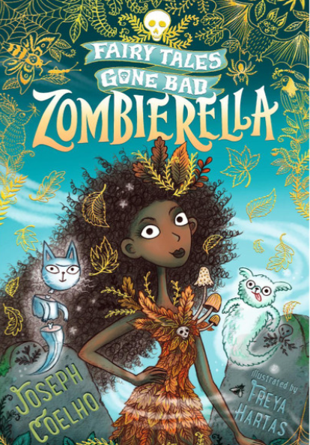
The books we will be enjoying this term include:
Tar Beach
Varmints
The undefeated
Zombierella
Farther
Until I met Dudley
The Wild Robot
Skygazing

Themes running throughout this term:
Finding Freedom, Invention and innovation, Why rainforests are important, Structures and buildings, Are all religions equal?
Family and Relationships.
Year 4
Autumn Learning Journey
In our topics, we will:

- Learn how food is digested in our bodies and why a balanced diet is important.
- Consider the importance of working collaboratively as part of a term and as individuals.
- How to build stable structures.
- How to make the sounds of the rainforest using body parts.
- Learn how describe people in French
- How to use Scratch to code.
- Use shading techniques for effect.
- How have the lives of children changed.
- Why Lord Shaftesbury was a significant individual in the lives of children.
- Why the Amazon rainforest is important.
As mathematicians, we will:
- Use ratio language
- Understand the link between ratio and fractions
- Complete scale drawings
- Use scale factors
- Solve ratio problems
- Form expressions in algebra
- Form equations in algebra
- Solve algebraic equations
- Multiply, divide, add and subtract decimals
- Convert between fractions, decimals and percentages.
As mathematicians, we will:
- Represent and partition numbers to 1,000
- Represent and partition numbers to 10,000
- Round to the nearest 10,100,1000
- Add and subtract two 4 digit numbers
- Estimate answers
- 3,6,7,9,11,12 times tables and division facts
- Identify and compare areas.
Year 5 Noticeboard:
Assessment Week – 13th October
Parents Evening – 22nd & 23rd October

