
As mathematicians, we will:
- Multiply and divide by 10 and 100.
- Multiply a 2 or 3 digit number by a 1 digit number.
- Measure in meters or Kilometers
- Calculate the perimeter of a rectilinear shape.
- Calculate the perimeter of a regular polygon
- Covert mixed numbers to improper fractions.
- Convert improper fractions to mixed numbers
- Add two fractions
- Subtract two fractions.
As writers, we will use:
Use a variety of verbs
Use similes to describe
Use a range of conjunctions (subordinating and coordinating)
Use a range of modal verbs
Write in the appropriate tense
As readers, we will:
- Give/explain the meaning of words in context
- Retrieve and record information
- Summarise main ideas
- Make inferences from the text
- Predict what might happen from details stated and implied
- Make comparisons within the text

Trips/ Visitors/ Workshops/ Parent Sharing
4th March World book day
3rd March colour run.

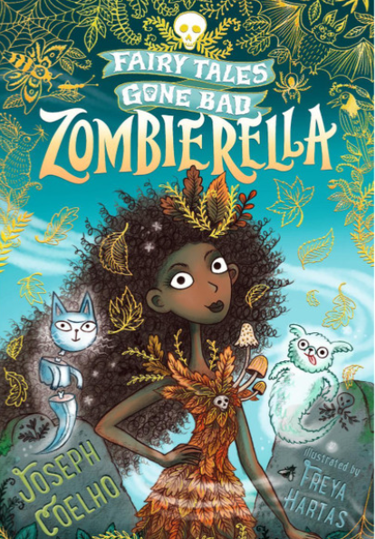
The books we will be enjoying this term include:
Friendleswylde
The Selfish Giant
The Firework Maker’s Daughter
Tamarind and the star of Ishta
The Lion and the Unicorn
The Matchbox Diary
Viking Voyages
Norse Myths
Themes running throughout this term:
Darkness and Light, Taking Courage, How hard was it to invade Britain? Where does our food come from? Mechanical Systems, How important are our beliefs, Economic wellbeing.
Year 4
Spring Learning Journey
In our topics, we will:

- Learn how and why certain solids, Liquids or gases can interchange.
- How sound travels.
- How can sound is measured.
- Why it is important to consider where our food comes.
- How food miles affect our environment.
- How we can be proactive citizens.
- Why the Anglo-Saxons came to settle in Britain.
- What makes an object good value.
- Why beliefs are important.
- How to use tints and shades to add a 3-d effect.

As mathematicians, we will:
- Use ratio language
- Understand the link between ratio and fractions
- Complete scale drawings
- Use scale factors
- Solve ratio problems
- Form expressions in algebra
- Form equations in algebra
- Solve algebraic equations
- Multiply, divide, add and subtract decimals
- Convert between fractions, decimals and percentages.
Year 5 Noticeboard:
Assessment Week – 13th October
Parents Evening – 22nd & 23rd October

