
Trips/ Visitors/ Workshops/ Parent Sharing
Jeans for Genes – 19th September
KS2 French Day – 13th October
Parent SATs Workshop – 6th October
Diwali Parent Lantern Workshop – 8th October
Children in Need – Wear what makes you happy – 21st November
KS2 Concert – 8th December

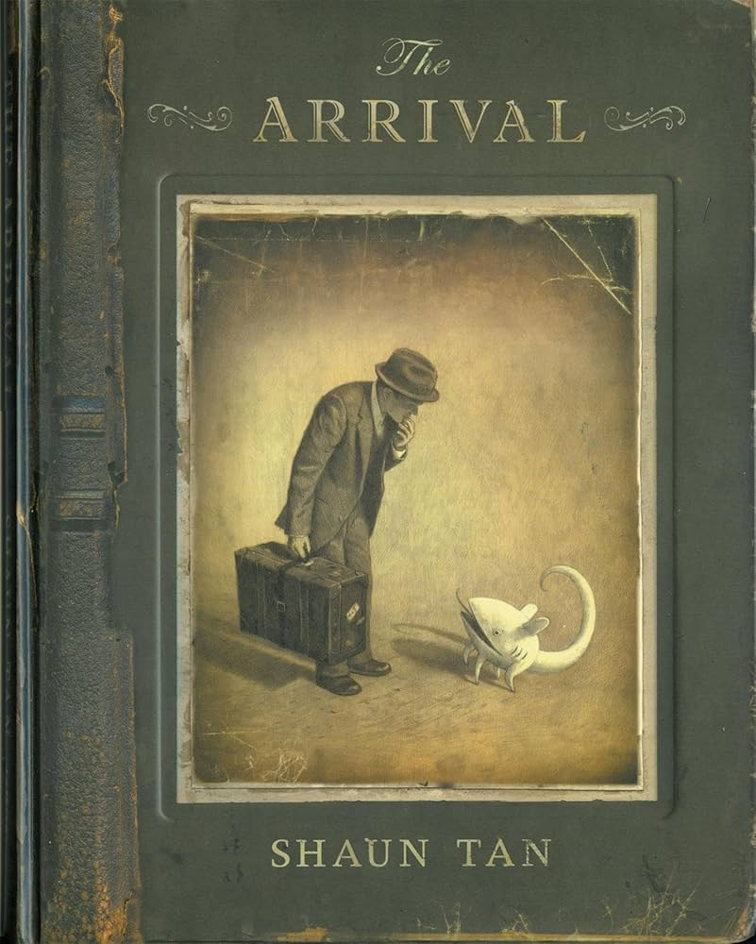
The books we will be enjoying this term include:
The Arrival
Leila and the Blue Fox
Can We Save The Tiger?
The Last Bear
Fly Me Home
On the Move
Beetle Boy
Darwin’s Voyage of Discovery

Themes running throughout this term:
Migration & Movement, Evolution & Inheritance, Classifying Big & Small, Why does population change?, Why does religion look different around the World?, Rights and Respect, Valuing Difference
Year 6
Autumn Learning Journey
In our topics, we will:

- Learn how to classify various living organisms.
- Explore how light travels.
- Use different types of technology to take photographs and edit them
- Understand the part that Bletchley Park played in the second world war
- Explore how data is used in everyday life
- Design and create playground equipment prototypes
- Investigation population levels and factors that may affect this
- Discuss how and why religion brings peace and conflict.
- Understand the importance of rights and respect and valuing difference.
As mathematicians, we will:
- Use ratio language
- Understand the link between ratio and fractions
- Complete scale drawings
- Use scale factors
- Solve ratio problems
- Form expressions in algebra
- Form equations in algebra
- Solve algebraic equations
- Multiply, divide, add and subtract decimals
- Convert between fractions, decimals and percentages.
As mathematicians, we will:
- Numbers to 10,000,000
- Powers of 10
- Compare and Order
- Round any Integer
- Negative Numbers
- Addition and Subtraction
- Common Factors
- Rules of Divisibility
- Primes to 100
- Multiplication and Division
- Mental Calculations
- Reason from Known Facts
As writers, we will use:
- Use conjunctions, adverbs, or prepositions
- Noun phrases expanded by the addition of modifying adjectives, nouns and preposition phrases
- Appropriate choice of pronoun or noun within and across sentences to aid cohesion
- Inverted commas to indicate direct speech
As readers, we will:
- Give/explain the meaning of words in context
- Retrieve and record information
- Summarise main ideas
- Make inferences from the text
- Predict what might happen from details stated and implied
- Make comparisons within the text

Year 6 Noticeboard:
LPPA Direction Meeting and Meet the Teacher will be on Wednesday 10th September.
Assessment Week – 13th October
Parents Evening – 22nd & 23rd October

