
Trips/ Visitors/ Workshops/ Parent Sharing

Storyteller Visit – 4th March
Colour Run – 4th March
Reading Café – 5th March
Science Day – 9th March
STEMFest – 18th March
Wacky Hair Day – 20th March
Parents Evening – 25th March & 26th March
In our topics, we will:

- Explore how we can use different drawing techniques to express our feelings and individuality.
- Investigate where our energy comes from.
- Understand how the people of Britain were impacted by World War II.
- Explore different types of music and scores from films.
- Understand the rules and techniques used in a game of handball.
- Explore different types of relationships and how we can maintain positive relationships.
- Learn about key French terms to describe our homes.
As mathematicians, we will:
- Use ratio language
- Understand the link between ratio and fractions
- Complete scale drawings
- Use scale factors
- Solve ratio problems
- Form expressions in algebra
- Form equations in algebra
- Solve algebraic equations
- Multiply, divide, add and subtract decimals
- Convert between fractions, decimals and percentages.
As mathematicians, we will:
- Use ratio language
- Understand the link between ratio and fractions
- Complete scale drawings
- Use scale factors
- Solve ratio problems
- Form expressions in algebra
- Form equations in algebra
- Solve algebraic equations
- Multiply, divide, add and subtract decimals
- Convert between fractions, decimals and percentages.
As writers, we will use:
- Use conjunctions, adverbs, or prepositions
- Noun phrases expanded by the addition of modifying adjectives, nouns and preposition phrases
- Appropriate choice of pronoun or noun within and across sentences to aid cohesion
- Inverted commas to indicate direct speech
As readers, we will:
- Give/explain the meaning of words in context
- Retrieve and record information
- Summarise main ideas
- Make inferences from the text
- Predict what might happen from details stated and implied
- Make comparisons within the text

The books we will be enjoying this term include:
Suffragette: The Battle for Equality
The invention of Hugo Cabret
The Three Little Pigs Project (visual literacy)
Boy in the Tower
Politics for Beginners
Caged Bird
The Wolves of Willoughby Chase

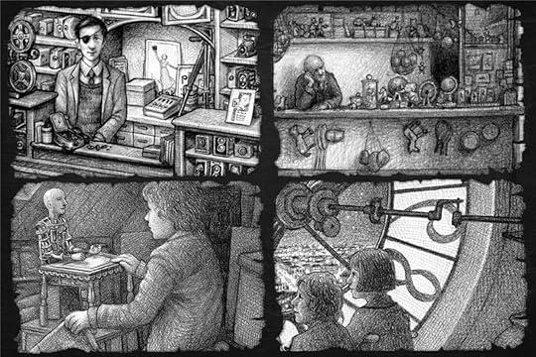
Year 6 Noticeboard:

Please make sure that you are completing your homework and reading five times every week.
Themes running throughout this term:
Enterprise & Activism, Utopia vs Dystopia, Making my voice heard, Navigating the World, Where does our energy come from?
Year 6
Spring Learning Journey

