
Year 5
Autumn Learning Journey
Themes running throughout this term:
Ambition and desire, Interactive Installation, What was life like in Tudor England?

As mathematicians, we will:

- Multiply, divide, add and subtract decimals.
- Place Value
- Add whole numbers with more than four-digit numbers.
- Use inverse operations.
- Compare Calculations.
As writers, we will use:

- Explore how a real-life story has been portrayed as fiction.
- Write letters of advice, considering the pros and cons.
- Write as witnesses and reporters and create updates for newspapers.

As readers, we will:
- Check that a books makes sense discussing understanding and exploring meaning of words in context.
- Inferring characters feeling, thoughts and motives from and justifying this with evidence.

The books we will be enjoying this term include:

- The Man Who Walked Between the Towers
- Robot Girl
- The Tempest
- The Good Thieves
- Cosmic
- Who Let the Gods Out
- Cogheart
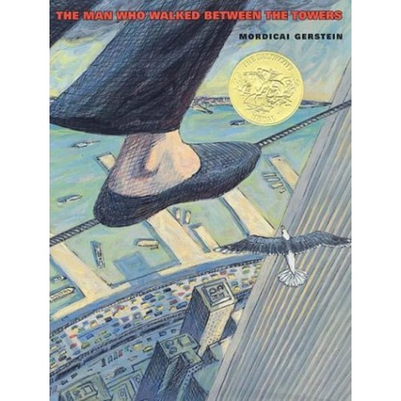

Year 5 Noticeboard:
Please make sure you are reading 5 times a week, completing TT Rockstars and are practising your spellings.

In our topics, we will:
- Exploring features of installation art and evaluating different prices of this type of artwork.
- Exploring different mixtures by creating some ourselves and researching common examples.
- Investigating whether or not Henry VIII was a fair ruler or tyrant.
- Learning the origins of blues music and identifying features of this genre.
- Locating the Alps on a map of Europe.

Trips/Visitors/Workshops/Parent Sharing

Jeans for Genes – 19th September
KS2 French Day – 13th October
Diwali Parent Lantern Workshop – 8th October Children in Need – Wear what makes you happy – 21st November KS2
The Globe Theatre/ Tate Modern Visit- 20th November

