
Year 5
Spring Learning Journey
Themes running throughout this term:
Belonging and equality, What did the Greeks ever do for us? Earth and space.
As mathematicians, we will:

• Multiply up to a 4-digit number by a 1- digit number.
• Multiply a 2-digit number by a 2-digit number.
• Multiply a unit fraction/non-unit fraction/mixed number by an integer.
• Cover decimals and percentages.
• Explore area and perimeter.

As writers, we will use:
• Devices to build cohesion within a paragraph
- Relative clauses beginning with who, which, where, when, whose, that, or an omitted relative pronoun.
- Figurative language to engage readers with expressive writing.

As readers, we will:
• Use retrieval and inference skills to answer questions.
• To be able to make predictions.

The books we will be enjoying this term include:
- Me, My Dad and the End of the Rainbow
- When the Stars Come Out
- Sir Gawain and the green Knight
- The Lost Thing
- Freedom Bird
- Beowulf
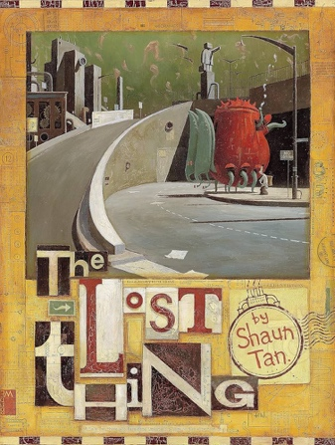

Year 5 Noticeboard:
Please make sure you are reading 5 times a week, completing your TT Rockstars and are practising your spellings.

In our topics, we will:
- Leaning about forces and space through the topic ‘Earth and Space’.
- Exploring stop motion animation.
- Investigating the question ‘What did the Greeks ever do for us?’
- Exploring the topic of why our Oceans matter and how they contribute to our survival.
- Learning about mechanical systems exploring gears and pulleys.
- Exploring scratch to programme music.

Trips/Visitors/Workshops/Parent Sharing

Storyteller Visit – 4th March
Colour Run – 4th March
World Book Day- 5th March
Reading Café – 5th March
Science Day – 9th March
STEMFest – 18th March
Wacky Hair Day – 20th March
Parents Evening – 25th March & 26th March

