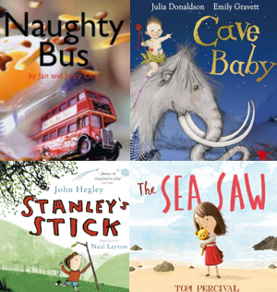

Year 1 Noticeboard:

- PE continues to be on Thursday afternoon.
- We visit the library and change phonics books every Friday.
- Our spelling test is on a Friday and new spellings are sent home.
- Assessment Week – 13th October
- Parents Evening – 22nd & 23rd October

The books we will be enjoying this term include:

Trips/ Visitors/ Workshops/ Parent Sharing

Jeans for Genes – 19th September
Children in Need – Wear what makes you happy – 21st
Year 1 Christmas card crafts with parents
Year 1 Christmas concert

In our topics, we will:

• Explore what different religions believe God looks like
• Explore different materials and their uses in real life. • Discuss the properties of different materials
• Observe differences between the seasons
• Explore different types of lines
• Use different lines to create our own art pieces
• Discuss what the past is
• Explore our own personal timelines
• Use maps and observations of our school and local area.
• Use cutting and joining techniques to make a windmill.
• Understand pulse and rhythm
• Clap and play along to the rhythm

As writers, we will:
• Saying out loud what they are going to write about
• Composing a sentence orally before writing it
• Sequencing sentences to form short narratives
• Re-reading what they have written to check that it makes sense
As readers, we will:
- Apply phonic knowledge and skills as the route to decode words
- Make inferences on the basis of what is being said and done
- Predict what might happen on the basis of what has been read so far
As mathematicians, we will:
- Sort and count objects
- Recognise numbers as words
- 1 more and 1 less
- Count forwards and backwards within 10
- Fewer, more and same
- Compare numbers
- Order objects and numbers
- Number bonds to 10
- Add and subtract within 10
- Recognise and name 2D and 3D shapes.
Themes running throughout this term:
How did the world begin? What do some people believe God looks like? Everyday materials, Seasonal changes, make your mark, Improving mouse skills, How am I making History? What is it like here? Constructing a Windmill, Pulse and Rhythm (my favourite things)
Year 1
Autumn Learning Journey

