
In our topics, we will:
- Develop skills in creating 3D sculptures through paper play
- Name and locate the four countries in the UK
- Describe seasonal changes
- Observe and describe weather patterns
- Make comparisons between toys in the past and toys in the present
- Recognise that different people have different beliefs about God’s from and appearance.
- Design and make a puppet
- Explain, write and follow an algorithm
- Explore musical vocabulary

Trips/ Visitors/ Workshops/ Parent Sharing
- KS1 New Year’s Disco – 8.1.26
- Dress like a Rockstar – 6.2.26
- Children’s Mental Health Week 9.2.26
- Sponsored Pancake Toss – 12.2.26
- Parinirvana Art Day – 13.2.26
- Lunar New Year – 23.2.26
- Author visit 4.3.26
- Colour Run – 4.3.26
- World Book Day – 5.3.26
- STEM Fest 18.3.26
- Red Nose Day 20.3.26
As writers, we will:
• Understand how words can combine to make sentences
• Join words and join clauses using ‘and’
• Sequence sentences to form short narratives
• Separate words with spaces
• Use capital letters, full stops, question marks and exclamation marks to demarcate sentences
• Use apostrophes to mark where letters are missing
As readers, we will:
- Apply phonic knowledge and skills as the route to decode words
- Make inferences on the basis of what is being said and done
- Predict what might happen on the basis of what has been read so far
As mathematicians, we will:
- Understand numbers up to 20
- Add and subtract numbers within 20
- Understand numbers within 50
- Compare and measure lengths and heights
- Compare and measure mass and volume
Year 1 Noticeboard:
- PE continues to be on Thursday afternoon.
- We visit the library and change phonics books every Friday.
- Our spelling test is on a Friday and new spellings are sent home.
- Assessment week – 2.2.26 and 16.3.26
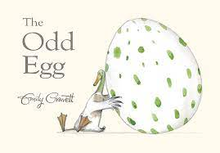
The books we will be enjoying this term include:

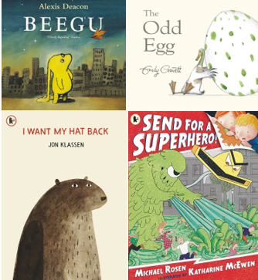

Themes running throughout this term:
Place Value, Volume and Height, Mass and Volume, How have toys changed?, Algorithms Unplugged, What is the weather like in the UK?, Sensitive bodies, Comparing animals, Why should we care for the world and others?, Economic Wellbeing, Ball Skills, Invasion Games, Puppets and Paper Play.
Year 1
Spring Learning Journey

