
In our topics, we will:
- Explore different habitats and microhabitats.
- Investigate how schools were different in the past.
- Explore and create techniques to create a piece of art.
- Investigate structures to make a chair
- Explore hot and cold places.
- Explore call and response pieces in music.
- Complete team building activities.
- Develop our ball skills.
- Explore what a computer is.
- Understand where we give thanks.
Year 2 Noticeboard:
LPPA Direction Meeting and Meet the Teacher will be on Wednesday 10th September.
Assessment Week – 13th October
Parents Evening – 22nd & 23rd October

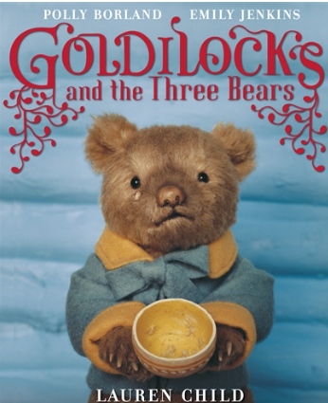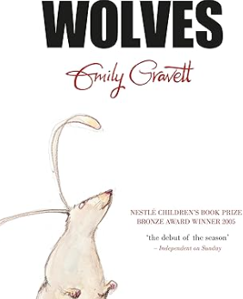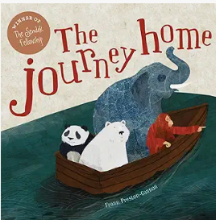
Trips/ Visitors/ Workshops/ Parent Sharing
Read, Write, Inc Workshop for EYFS and KS1 parents – 16th September
Jeans for Genes – 19th September
Diwali Parent Lantern Workshop – 8th October
Adopt a Chef – 14th October
Enterprise Week – w/b 20th October
Roman Workshop – 23rd October
Enterprise Day – 24th October
Children in Need – Wear what makes you happy – 21st November
KS1 Concert – 16th December
Christmas card making – 17th December

As mathematicians, we will:
- Use ratio language
- Understand the link between ratio and fractions
- Complete scale drawings
- Use scale factors
- Solve ratio problems
- Form expressions in algebra
- Form equations in algebra
- Solve algebraic equations
- Multiply, divide, add and subtract decimals
- Convert between fractions, decimals and percentages.
As mathematicians, we will:
- Reading and writing numbers to 100
- Understanding the value of digits in a 2 digit number
- Counting in 2, 5 and 10
- Add and subtract using a range of mental methods
- Add and subtract within a ten and crossing a ten
- Naming 2D and 3D shapes and identifying their properties
- Lines of symmetry
As writers, we will use:
• Apostrophes for contractions and possessions
• The correct spellings for words with suffixes
• The past and present tenses consistently
• Co-ordination and subordination to join clauses
As readers, we will:
•Read accurately by blending sounds in words that contain two or more syllables
•Read words containing common suffixes
•Ask and answer questions about the books we are reading
The books we will be enjoying this term include:
Goldilocks & the Three Bears
Wolves
The Journey Home

Themes running throughout this term:
Would I rather live in a hot or cold place? Would I rather go to school now or in the past? Habitats and microhabitats
Year 2
Autumn Learning Journey

